EV market sales Dashboard 2026
Step 1:
Major question to find the insights :
- Which brands dominate the market?
- Which vehicles offer the best value for money?
- What features drive sales?
- What affects customer ratings?
- Which market segments are growing?
- Which EVs are future-proof?

Cleaning/Prepare Data:
- Clean and remove null values.
- Set correct data types.
Power Query
- Create calculated columns:
  - Price Category (Budget/Mid/Luxury)
  - Battery Category
  - Range Category
  - Performance Category
  - Vehicle Age
Key DAX Measures
- Total Sales
- Average Price
- Average Range
- Average Battery Capacity
- Average Charging Speed
- Average Customer Rating
- Average Safety Rating
- Total Brands
- Total Models
- Battery Efficiency (Range ÷ Battery Capacity)
- Price per Mile
- Brand Rank & Model Rank
KPIs
- Total Sales Units
- Best Selling Brand
- Best Selling Model
- Average Price
- Average Range
- Average Rating
- Average Charging Speed
- Battery Efficiency
- Safety Rating
- Luxury vs Budget Vehicle %
Dashboard Pages
- Overview – KPI cards, Sales by Brand, Country, Year, Top brands, top models, market share.
- Performance Analysis – Battery vs Range, Price vs Horsepower, Charging Speed, Ratings, Warranty, Safety.
- Market Analysis – Sales by Country, Segment, Body Type, Drive Type.
Interactive Features
- Slicers: Brand, Year, Country, Segment, Drive Type, Body Type.
- Drill-through to Brand/Model details.
- Dynamic Tooltips.
- Bookmarks for easy navigation.
Business Insights
- Identify top-selling brands and models.
- Compare value for money (Price vs Range).
- Analyze factors affecting customer ratings.
- Measure battery efficiency.
- Discover high-growth market segments.
- Predict future demand based on sales trends, battery performance, and customer satisfaction.
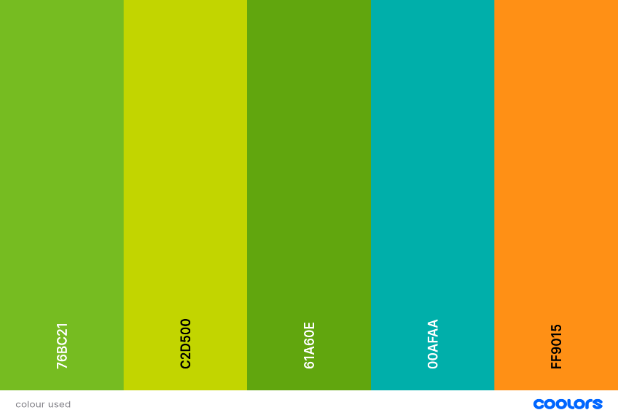

Colour Palate Hex code
- #76bc21
- #c2d500
- #61a60e
- #00afaa
- #ff9015

